Lab 12:

1. Write SQL code to create view from EmployeeDetails Table
2. List data from view
3. List data items using different operators
4. Create view from multiple table and display data

SQL Query:

* CREATE DATABASE db12;

USE db12;

* CREATE TABLE Employees (

emp_id INT PRIMARY KEY,

NAME VARCHAR(100),

salary INT,

department VARCHAR(100),

dob DATE,

dept_id INT

);

* CREATE TABLE Departments (

dept_id INT PRIMARY KEY,

dept_name VARCHAR(100)

);

* INSERT INTO Employees VALUES

(1, 'Patrick Mendoza', 120000, 'Initiator', '2001-12-05', 1),

(2, 'Wang Jing Jie', 110000, 'Dualist', '2003-07-27', 3),

(3, 'Jason Susanto', 105000, 'Controller', '2004-03-25', 2),

(4, 'Khalish Rusyaidee', 95000, 'Initiator', '1998-10-14', 1),

(5, 'Spencer Martin', 90000, 'Dualist', '1995-6-27', 3);

* INSERT INTO Departments VALUES

(1, 'Initiator'),

(2, 'Controller'),

(3, 'Dualist');

* CREATE VIEW EmployeeDetails AS

SELECT emp_id, NAME, salary, department, dob

FROM Employees;

SELECT * FROM EmployeeDetails;

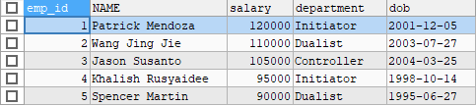

* SELECT * FROM EmployeeDetails

WHERE salary > 100000;

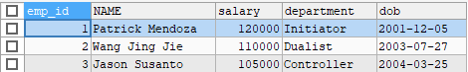

* SELECT * FROM EmployeeDetails

WHERE NAME LIKE 'W%';



* SELECT * FROM EmployeeDetails

WHERE dob BETWEEN '1996-01-01' AND '2002-01-01';



* SELECT * FROM EmployeeDetails

WHERE department IN ('Initiator', 'Controller');

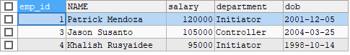

* CREATE VIEW EmployeeWithDept AS

SELECT

E.emp_id,

E.name,

E.salary,

D.dept_name

FROM

Employees E

JOIN

Departments D ON E.dept_id = D.dept_id;

SELECT * FROM EmployeeWithDept;

